Readme-AtliQ Hardware

Aim: Review Sales Performance for AtliQ hardware store.

Step 1:

Imported data from GitHub into SQL Workbench

Step2: Wrote an SQL script to retrieve and explore all the relevant data for sales insights

**#Show total number of customers**

SELECT count(*) FROM customers;

**#Show transactions for Chennai market (market code for chennai is Mark001**

SELECT * FROM transactions where market_code='Mark001';

#**Show distrinct product codes that were sold in chennai**

SELECT distinct product_code FROM transactions where market_code='Mark001';

**#show transactions where currency is US dollars**

SELECT * from transactions where currency="USD"

**#Show transactions in 2020 join by date table**

SELECT transactions.*, date.* FROM transactions INNER JOIN date ON transactions.order_date=date.date where date.year=2020;

**#Show total revenue in year 2020,**

SELECT SUM(transactions.sales_amount) FROM transactions

INNER JOIN date

ON transactions.order_date=date.date where date.year=2020 and transactions.currency="INR" or transactions.currency="USD";

**#Show total revenue in year 2020, January Month**

SELECT SUM(transactions.sales_amount) FROM transaction

INNER JOIN date

ON transactions.order_date=date.date

where date.year=2020 and

date.month_name="January" and (transactions.currency="INR" or transactions.currency="USD");

**#Show total revenue in year 2020 in Chennai**

SELECT SUM(transactions.sales_amount) FROM transactions INNER JOIN date ON transactions.order_date=date.date where date.year=2020 and transactions.market_code="Mark001";

Step 3:

Connected SQL Database to PowerBI

Step 4: Established relationships between the tables which had the same columns.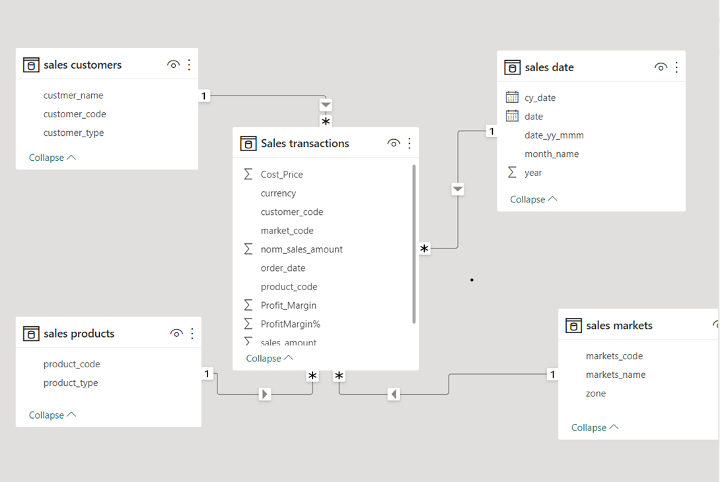

Step 4: Performed the ETL process

Sales Amount, where Sales Amount=0 or Sales Amount=-1, I replaced the data with the Sales Amount=1

Converted Products which were in USD currency into Rupees by creating a calculated column

Removed rows that contained Market codes were not in India

Dashboard:

